**Ramolatela Lebaea**

**221064591**

System That Displays Real-Time Hours, Minutes, And Seconds On A 7-Segment Display. Specifically, Use Three 7-Segment Displays To Indicate Minutes And Seconds, With One Display For Minutes And Two For Seconds.

The objectives of this project are to design and implement a system that displays real-time hours, minutes, and seconds on a 7-segment display, specifically using three 7-segment displays to indicate minutes and seconds, with one display for minutes and two for seconds. Additionally, the project aims to gain more knowledge about the “SevSeg” library and how to connect more than one digit seven-segment display to perform a particular function. A real-time timer, or RTC, is a specialized electronic device that accurately tracks time and date, including seconds, minutes, hours, days, months, and years. It features a battery backup to maintain timekeeping during power outages, supports alarms for event scheduling, and communicates with other devices using I2C or SPI interfaces. RTCs are essential components in various applications, from consumer devices like watches to industrial systems, ensuring precise time and date information for tasks such as data logging, event scheduling, and network synchronization through protocols like NTP.

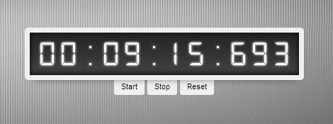

# [This Photo](http://maxembedded.com/2011/06/avr-timers-timer2/) by Unknown Author is licensed under [CC BY-NC-ND](https://creativecommons.org/licenses/by-nc-nd/3.0/).

# APPARATUS

* 1× 3 or 4-digit segment display
* 2× push buttons
* 1× Breadboard
* 1× Microcontroller board (ESP32 board)
* Connecting wires

# CIRCUIT DIAGRAM AND DATASHEETS

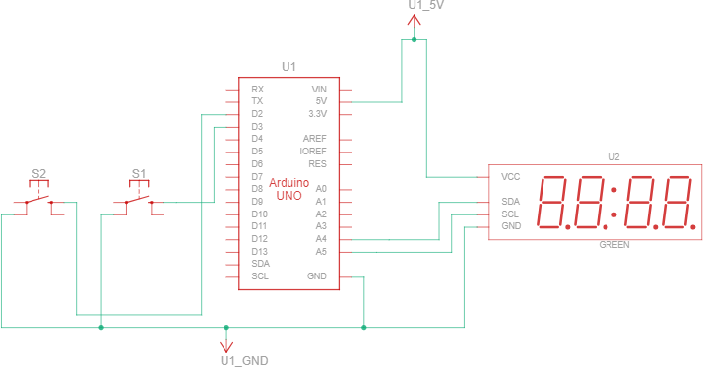

NB: On this circuit, I just used an Arduino and a 12C 7-segment display because I couldn’t find the ESP32 and SPI seven-segment display on Tinkercad software.

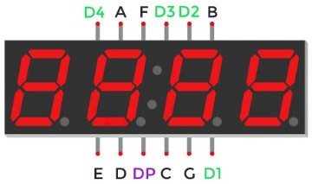

}

# OUTPUT AND ANALYSIS OF RESULTS

*Sev Seg before pressing any PB*

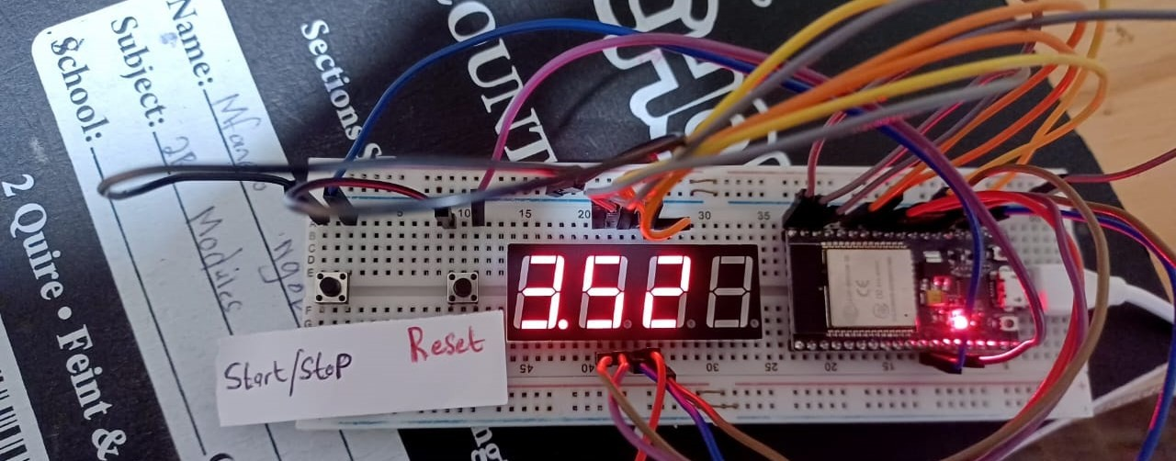

*Sev Seg After Start/Stop PB is pressed*

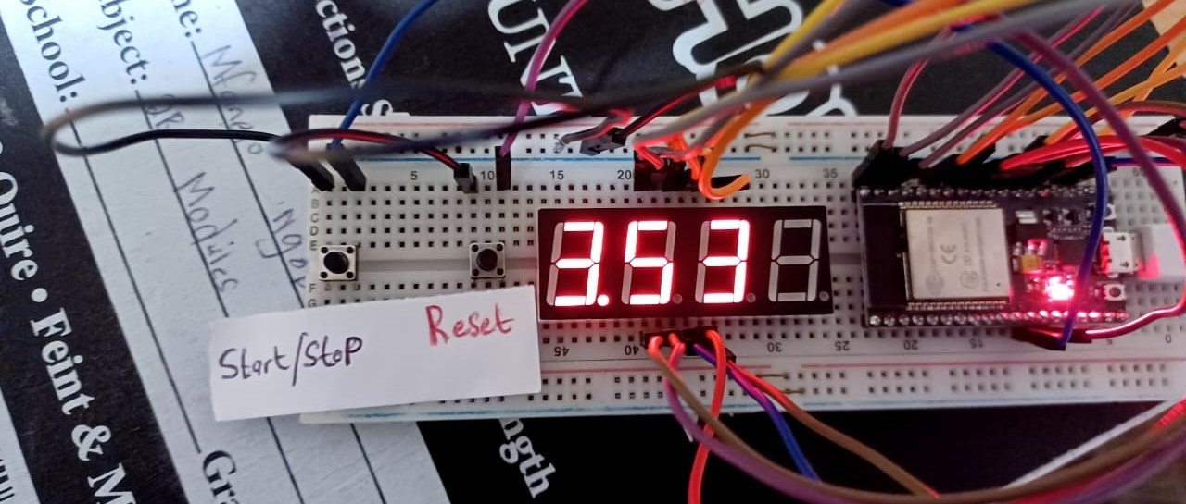

*Sev Seg After Start/Stop PB is pressed to continue from where it stopped*

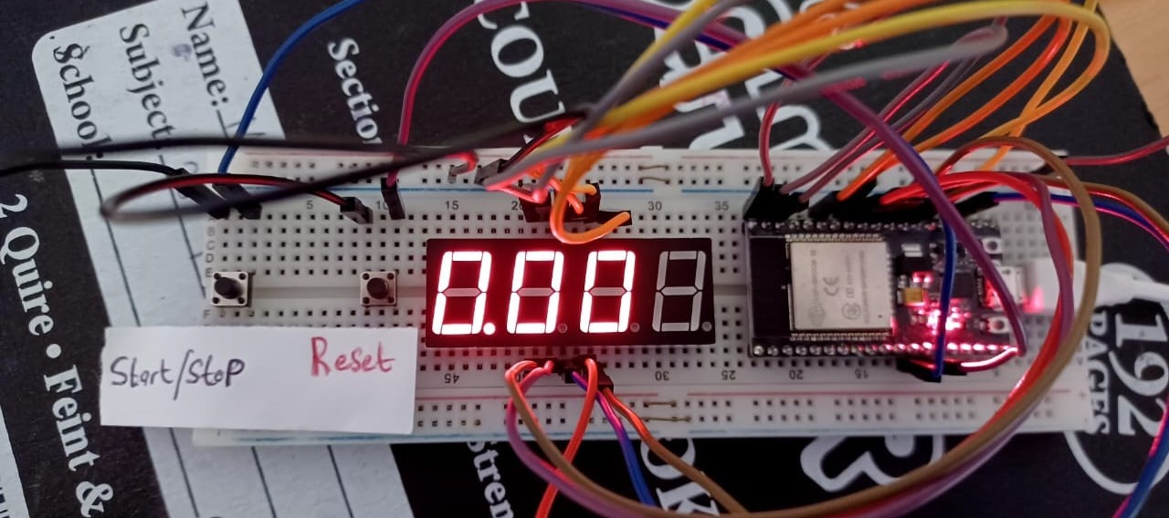

*Figure 7: Sev Seg After Reset PB*

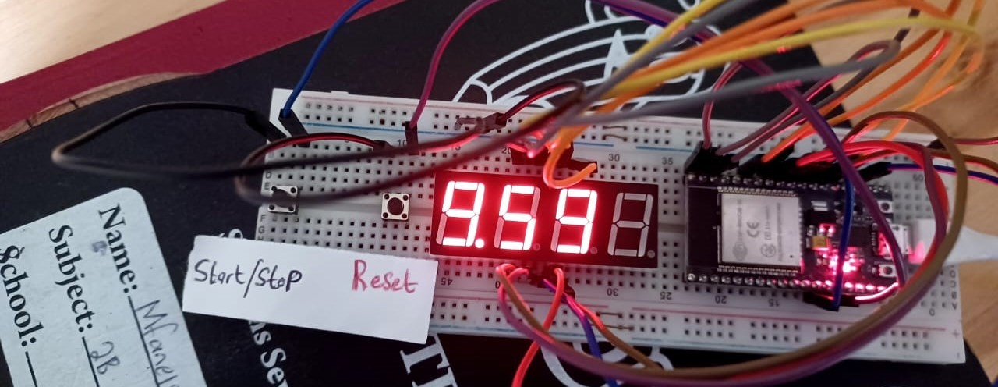

*Sev Seg Output*

Firstly I am using a 4-digit segment display, but only three are activated, and one is not. So when the board is powered up, all three activated digits of the segment display display ‘0’ until the reset or start/stop button is pressed, as shown in Figure: 4 above. Both the reset and start/stop buttons can start the timer, but they have different functions. The start/stop button is used to start the timer or to stop the timer if it was counting before. The reset button can start the timer as well but its main purpose is to restart the timer to start afresh from “0:00” when pressed, as shown in Figure: 7. So when the timer starts, it can count to 9 minutes and 59 seconds since the first digit of the 7 seg displays the minutes and the other two display the second, hence the maximum it can reach is 9 minutes and 59 seconds. So after “9:59”, the timer starts counting from “0:00”, and so on.

The display indicated minutes, and seconds, with two buttons for resetting and starting/stopping the timer. The timer accurately counted up to 9 minutes and 59 seconds before resetting, meeting the assignment's objectives. I found this practical helpful, It helped me become proficient in handling timer tasks using multi-digit 7-segment displays, and I also improved my understanding of how the millis() function works in practice.

# REFERENCES

1. ALLABOUTCIRCUITS. (n.d). *Real Time Clocks (RTCs) in Microcontroller Timers*. Available at: [https://www.allaboutcircuits.com/technical-articles/introduction-to-](https://www.allaboutcircuits.com/technical-articles/introduction-to-microcontrollertimersrealtimeclocks/#%3A~%3Atext%3DReal%2Dtime%20clocks%20(RTC)%2Caccuracy%20and%20very%20reliable%20operation) [microcontrollertimersrealtimeclocks/#:~:text=Real%2Dtime%20clocks%20(RTC),accuracy%](https://www.allaboutcircuits.com/technical-articles/introduction-to-microcontrollertimersrealtimeclocks/#%3A~%3Atext%3DReal%2Dtime%20clocks%20(RTC)%2Caccuracy%20and%20very%20reliable%20operation) [20and%20very%20reliable%20operation](https://www.allaboutcircuits.com/technical-articles/introduction-to-microcontrollertimersrealtimeclocks/#%3A~%3Atext%3DReal%2Dtime%20clocks%20(RTC)%2Caccuracy%20and%20very%20reliable%20operation) . (Accessed: September 13, 2023).